Test Case: tc002_SPX_Dev5_Crear_Requisicion_Spot_Tipo_Cobro_Project
Step 1 - Enter username and password and click to button Enter: Credentials Entered
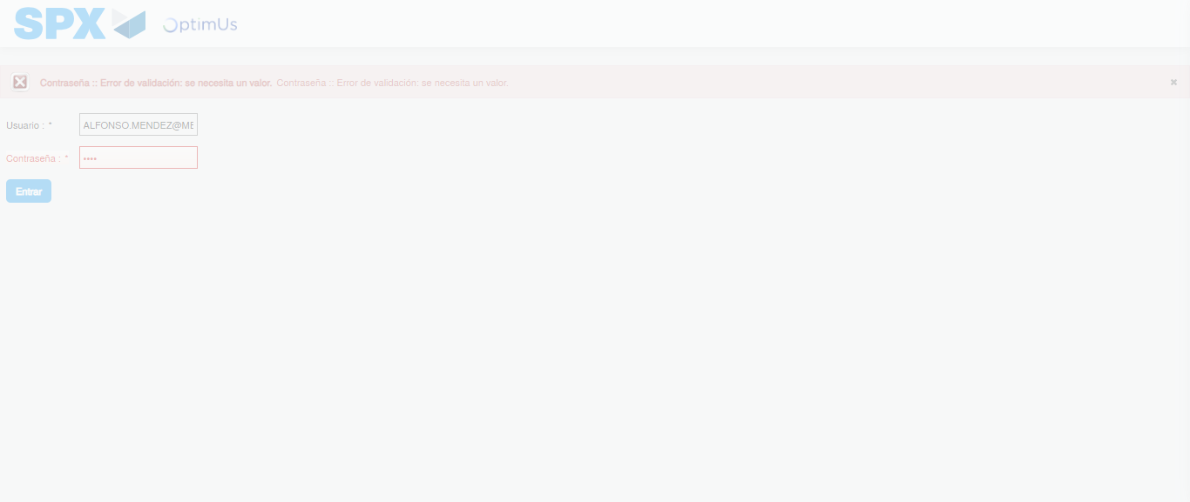Image file-name: QC_Testing-tc002_SPX_Dev5_Crear_Requisicion_Spot_Tipo_Cobro_Project-1783381644438

Step 2 - Select to UEN and Access to Spot Buy Requisitions : UEN Correctly selected and Correct access
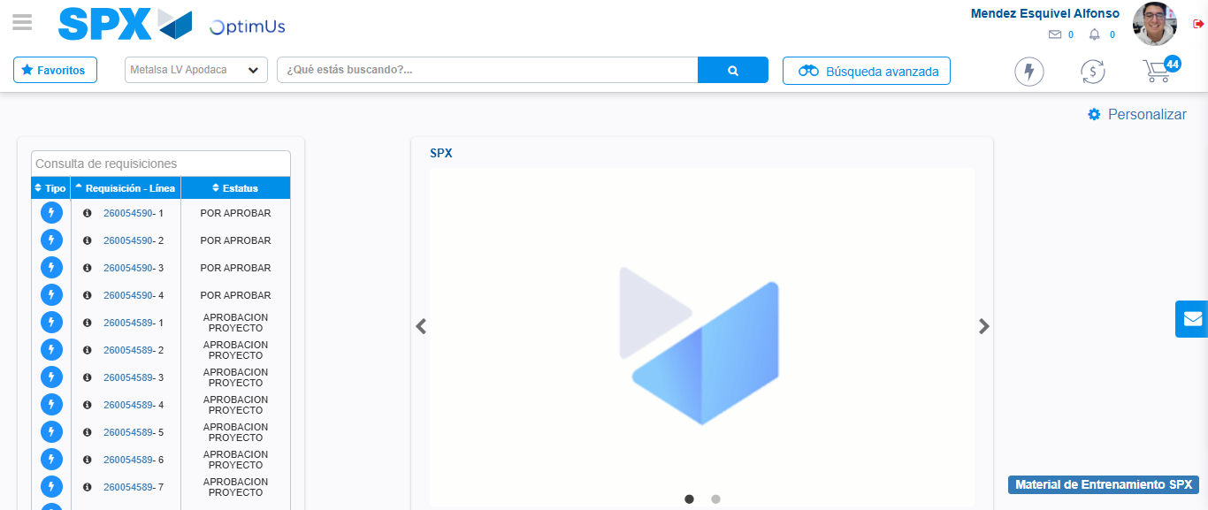Image file-name: QC_Testing-tc002_SPX_Dev5_Crear_Requisicion_Spot_Tipo_Cobro_Project-1783381670148

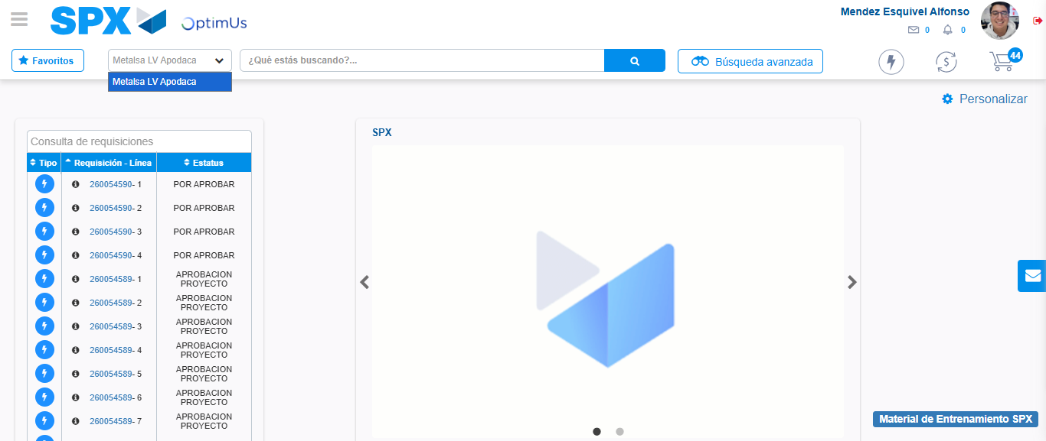Image file-name: QC_Testing-tc002_SPX_Dev5_Crear_Requisicion_Spot_Tipo_Cobro_Project-1783381672669

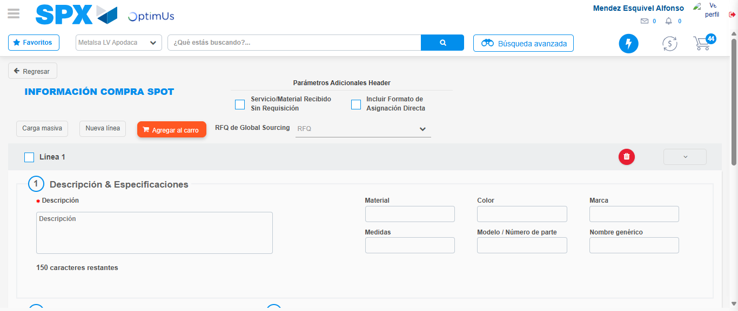Image file-name: QC_Testing-tc002_SPX_Dev5_Crear_Requisicion_Spot_Tipo_Cobro_Project-1783381694542

Step 3 - Data Capture Spot Buy Requisition: Data captured correctly
Image file-name: QC_Testing-tc002_SPX_Dev5_Crear_Requisicion_Spot_Tipo_Cobro_Project-1783381694783

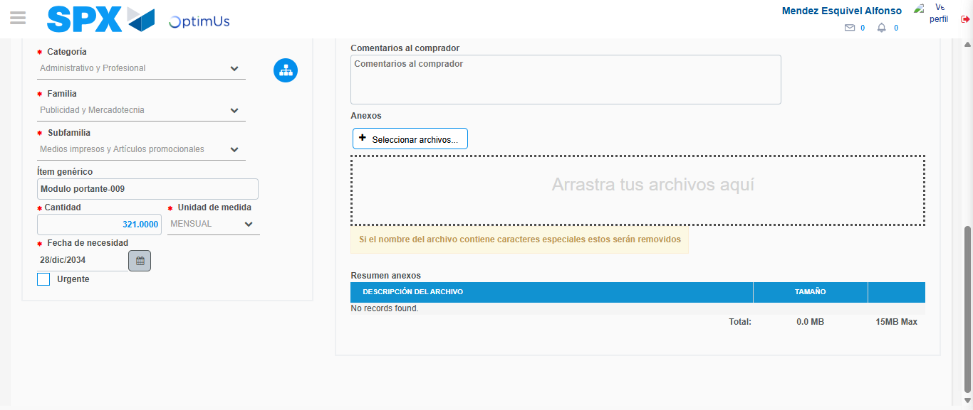Image file-name: QC_Testing-tc002_SPX_Dev5_Crear_Requisicion_Spot_Tipo_Cobro_Project-1783381704322

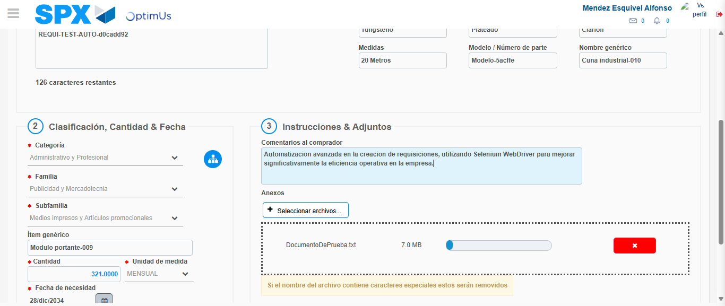Image file-name: QC_Testing-tc002_SPX_Dev5_Crear_Requisicion_Spot_Tipo_Cobro_Project-1783381705116

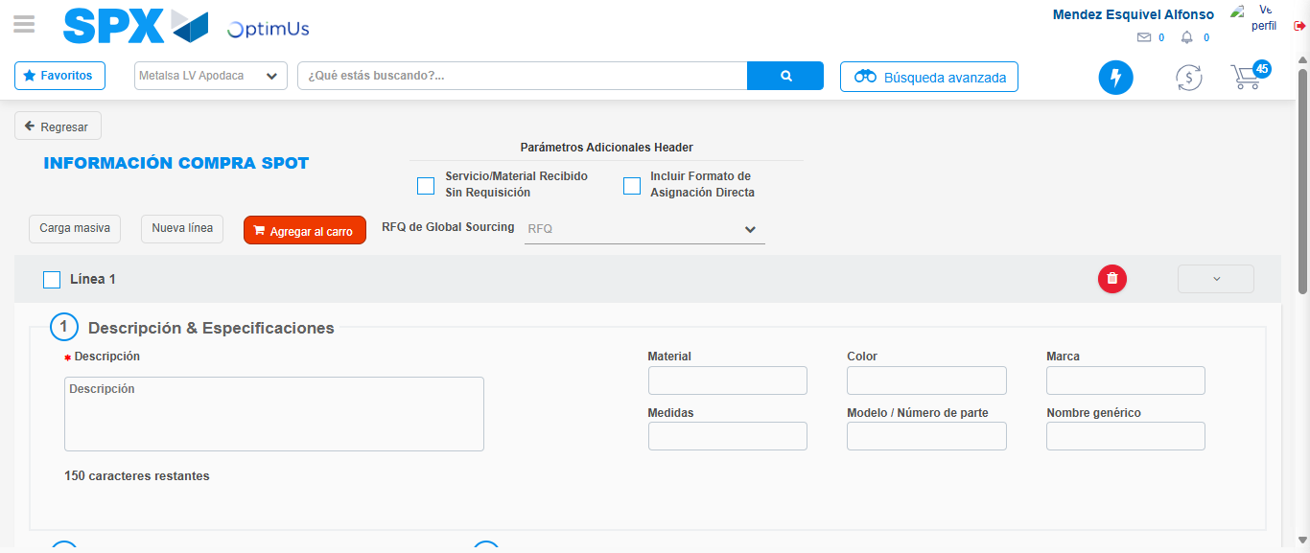Image file-name: QC_Testing-tc002_SPX_Dev5_Crear_Requisicion_Spot_Tipo_Cobro_Project-1783381715624

Step 7 - Return to Main Page SPX : Return to Main Page SPX
Image file-name: QC_Testing-tc002_SPX_Dev5_Crear_Requisicion_Spot_Tipo_Cobro_Project-1783381670148

Image file-name: QC_Testing-tc002_SPX_Dev5_Crear_Requisicion_Spot_Tipo_Cobro_Project-1783381672669

Image file-name: QC_Testing-tc002_SPX_Dev5_Crear_Requisicion_Spot_Tipo_Cobro_Project-1783381694542

Image file-name: QC_Testing-tc002_SPX_Dev5_Crear_Requisicion_Spot_Tipo_Cobro_Project-1783381717865

Image file-name: QC_Testing-tc002_SPX_Dev5_Crear_Requisicion_Spot_Tipo_Cobro_Project-1783381718051

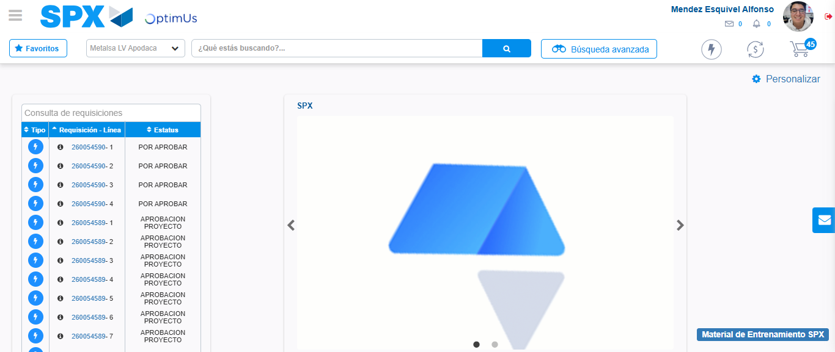Image file-name: QC_Testing-tc002_SPX_Dev5_Crear_Requisicion_Spot_Tipo_Cobro_Project-1783381739089

Step 8 - Log Out : Log Out SPX
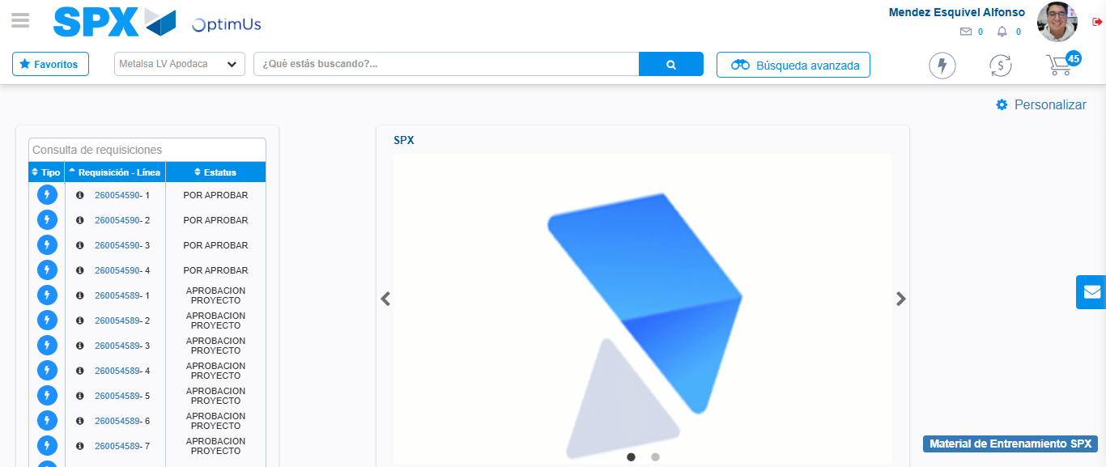Image file-name: QC_Testing-tc002_SPX_Dev5_Crear_Requisicion_Spot_Tipo_Cobro_Project-1783381739345

